Prescott, AZ Travel and Motel Information
“This Moment This Love Retreat” at Skyview School

Travel by Car:

Directions to Prescott from the South: Take I-17 north to the Highway 69 exit into Prescott. Highway 69 turns into Gurley Street, which goes into downtown Prescott.
Directions to Prescott from the North: Take I-17 south to the Highway 169 (Cherry Road) exit and turn right. Continue on 169 to Dewey, where it meets Highway 69 at a T intersection. Turn right onto Highway 69 and follow it into Prescott. Highway 69 turns into Gurley Street, which goes into downtown Prescott.
From Gurley St. to Skyview School: Coming into Prescott on Highway 69, take Gurley St. Turn
left on S. Rush St. Skyview School is on the left in the first block after turning. The school is set back from the street a bit. The entrance to the driveway is at the far end of the block.

Map to Skyview School:
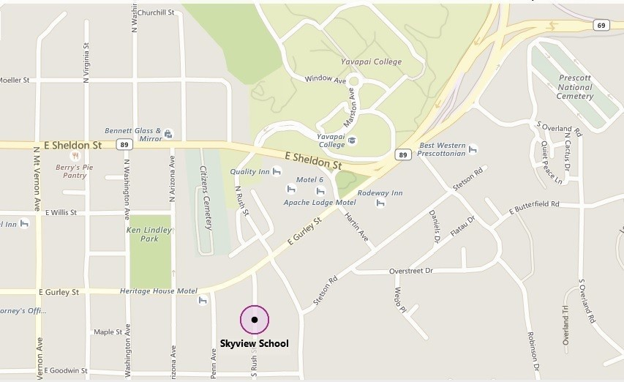

Flight/airport info:
Fly into Phoenix and catch a shuttle or you can connect to a commuter flight to the Prescott airport (less reliable flight scheduling). Prescott is a 2-hour drive or shuttle ride from the Phoenix Sky Harbor Airport. Reservations for the Arizona Shuttle to and from the Phoenix airport can be made online (arizonashuttle.com) for a cost of $35.00 one way ($70 round trip), or by calling (800)888-2749. For an additional $8.50, they will deliver you directly to the retreat site. This fee is per reservation, so if two of you are traveling together & have put the shuttle ride on one credit card, it will be $8.50 for the two of you.

Taxis available in the Prescott Area:
Dial-A-Ride Taxi (928) 776-7433
AAA Taxi (928) 708-0800
Classic Taxi (928) 277-4416
Prescott Yellow Cab (928) 777-TAXI (8294)
Speedy Taxi (928) 445-0123

Group Discount Hotel Rooms - information coming soon …. Additional Prescott, AZ Motel and Camping Information
This is a good website for checking out Prescott motels: http:// www.tripadvisor.com/Hotels-g31323-Prescott_Arizona-Hotels.html
St Michael's Hotel, Hotel Vendome, and Hassayampa Inn are quaint and located in the historic downtown part of Prescott, which is convenient to the retreat.
Springhill Suites is pleasant and newer, close to downtown in a shopping plaza.
America's Best Value Inn, Motel 6, and Best Western Prescottonian are standard fare.
The Apache Lodge is "rustic & retro."
The Comfort Inn is basic lodging quite close to the retreat location.
The Motor Lodge is conveniently nearby and each room has a unique theme. Also check out the B&B/Inns tab on the tripadvisor page, for other possibilities.
We also have campgrounds. You can read more about these at http:// www.forestcamping.com/dow/southwst/prescmp.htm

Prescott Peace Dances and Sufi Circle – www.prescottcircle.org

